20.39: The initial volume is 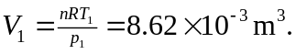 a) At point 1, the pressure
is given as atmospheric, and 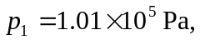with the volume found above, 